Module-8

Reflection

Reflection of light
Reflection of light is either specular (mirror-like) or diffuse (retaining the energy, but losing the image) depending on the nature of the interface. In specular reflection the phase of the reflected waves depends on the choice of the origin of coordinates, but the relative phase between s and p (TE and TM) polarizations is fixed by the properties of the media and of the interface between them.
A mirror provides the most common model for specular light reflection, and typically consists of a glass sheet with a metallic coating where the significant reflection occurs. Reflection is enhanced in metals by suppression of wave propagation beyond their skin depths. Reflection also occurs at the surface of transparent media, such as water or glass.
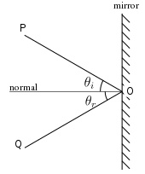
Fig 1. Diagram of specular reflection
In the diagram, a light ray PO strikes a vertical mirror at point O, and the reflected ray is OQ. By projecting an imaginary line through point O perpendicular to the mirror, known as the normal, we can measure the angle of incidence, θ_{i} and the angle of reflection, θ_{r}. The law of reflection states that θ_{i} = θ_{r}, or in other words, the angle of incidence equals the angle of reflection.
In fact, reflection of light may occur whenever light travels from a medium of a given refractive index into a medium with a different refractive index. In the most general case, a certain fraction of the light is reflected from the interface, and the remainder is refracted. Solving Maxwell's equations for a light ray striking a boundary allows the derivation of the Fresnel equations, which can be used to predict how much of the light is reflected, and how much is refracted in a given situation. This is analogous to the way impedance mismatch in an electric circuit causes reflection of signals. Total internal reflection of light from a denser medium occurs if the angle of incidence is greater than the critical angle.
Total internal reflection is used as a means of focusing waves that cannot effectively be reflected by common means. X-ray telescopes are constructed by creating a converging "tunnel" for the waves. As the waves interact at low angle with the surface of this tunnel they are reflected toward the focus point (or toward another interaction with the tunnel surface, eventually being directed to the detector at the focus). A conventional reflector would be useless as the X-rays would simply pass through the intended reflector.
When light reflects off of a material with higher refractive index than the medium in which is traveling, it undergoes a 180° phase shift. In contrast, when light reflects off of a material with lower refractive index the reflected light is in phase with the incident light. This is an important principle in the field of thin-film optics.
Specular reflection forms images. Reflection from a flat surface forms a mirror image, which appears to be reversed from left to right because we compare the image we see to what we would see if we were rotated into the position of the image. Specular reflection at a curved surface forms an image which may be magnified or demagnified; curved mirrors have optical power. Such mirrors may have surfaces that are spherical or parabolic.
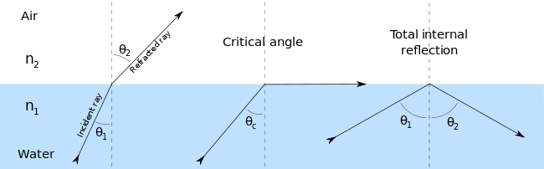
Fig 2. Refraction of light at the interface between two media.

Laws of reflection

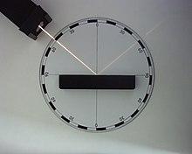
Fig 3. An example of the law of reflection
If the reflecting surface is very smooth, the reflection of light that occurs is called specular or regular reflection. The laws of reflection are as follows:
- The incident ray, the reflected ray and the normal to the reflection surface at the point of the incidence lie in the same plane.
- The angle which the incident ray makes with the normal is equal to the angle which the reflected ray makes to the same normal.
- The reflected ray and the incident ray are on the opposite sides of the normal.
These three laws can all be derived from the Fresnel equations.

Mechanism
Fig 4. 2D simulation: reflection of a quantum particle. White blur represents the probability distribution of finding a particle in a given place if measured.
In classical electrodynamics, light is considered as an electromagnetic wave, which is described by Maxwell's equations. Light waves incident on a material induce small oscillations of polarisation in the individual atoms (or oscillation of electrons, in metals), causing each particle to radiate a small secondary wave in all directions, like a dipole antenna. All these waves add up to give specular reflection and refraction, according to the Huygens–Fresnel principle.
In the case of dielectrics such as glass, the electric field of the light acts on the electrons in the material, and the moving electrons generate fields and become new radiators. The refracted light in the glass is the combination of the forward radiation of the electrons and the incident light. The reflected light is the combination of the backward radiation of all of the electrons.
In metals, electrons with no binding energy are called free electrons. When these electrons oscillate with the incident light, the phase difference between their radiation field and the incident field is π (180°), so the forward radiation cancels the incident light, and backward radiation is just the reflected light.
Light–matter interaction in terms of photons is a topic of quantum electrodynamics, and is described in detail by Richard Feynman in his popular book QED: The Strange Theory of Light and Matter.
Refraction, is, the change in direction of a wave passing from one medium to another caused by its change in speed. For example, waves in deep water travel faster than in shallow. If an ocean wave approaches a beach obliquely, the part of the wave farther from the beach will move faster than that closer in, and so the wave will swing around until it moves in a direction perpendicular to the shoreline.

Diffuse reflection
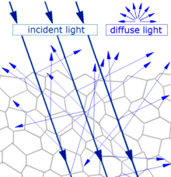
Fig 5. General scattering mechanism which gives diffuse reflection by a solid surface
When light strikes the surface of a (non-metallic) material it bounces off in all directions due to multiple reflections by the microscopic irregularities inside the material (e.g. the grain boundaries of a polycrystalline material, or the cell or fiber boundaries of an organic material) and by its surface, if it is rough. Thus, an 'image' is not formed. This is called diffuse reflection. The exact form of the reflection depends on the structure of the material. One common model for diffuse reflection is Lambertian reflectance, in which the light is reflected with equal luminance (in photometry) or radiance (in radiometry) in all directions, as defined by Lambert's cosine law.
The light sent to our eyes by most of the objects we see is due to diffuse reflection from their surface, so that this is our primary mechanism of physical observation.
Refraction through Prism:
The electromagnetic waves constituting light are refracted when crossing the boundary from one transparent medium to another because of their change in speed. A straight stick appears bent when partly immersed in water and viewed at an angle to the surface other than 90°. A ray of light of one wavelength, or colour (different wavelengths appear as different colours to the human eye), in passing from air to glass is refracted, or bent, by an amount that depends on its speed in air and glass, the two speeds depending on the wavelength. A ray of sunlight is composed of many wavelengths that in combination appear to be colourless. Upon entering a glass prism, the different refractions of the various wavelengths spread them apart as in a rainbow
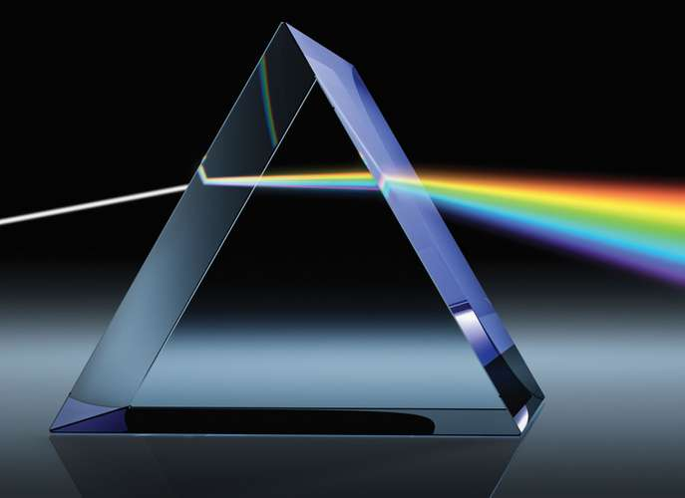
Fig 6. Refraction through Prism
Optical fiber:
An optical fiber is a flexible, transparent fiber made by drawing glass (silica) or plastic to a diameter slightly thicker than that of a human hair. Optical fibers are used most often as a means to transmit light between the two ends of the fiber and find wide usage in fiber-optic communications, where they permit transmission over longer distances and at higher bandwidths (data rates) than electrical cables.

Fiber-Optic Characteristics
Optical-fiber systems have many advantages over metallic-based communication systems. These advantages include interference, attenuation, and bandwidth characteristics. Furthermore, the relatively smaller cross section of fiber-optic cables allows room for substantial growth of the capacity in existing conduits. Fiber-optic characteristics can be classified as linear and nonlinear. Nonlinear characteristics are influenced by parameters, such as bit rates, channel spacing, and power levels.

Interference
Light signals traveling via a fiber-optic cable are immune from electromagnetic interference (EMI) and radio-frequency interference (RFI). Lightning and high-voltage interference is also eliminated. A fiber network is best for conditions in which EMI or RFI interference is heavy or safe operation free from sparks and static is a must. This desirable property of fiber-optic cable makes it the medium of choice in industrial and biomedical networks. It is also possible to place fiber cable into natural-gas pipelines and use the pipelines as the conduit.

Linear Characteristics
Linear characteristics include attenuation, chromatic dispersion (CD), polarization mode dispersion (PMD), and optical signal-to-noise ratio (OSNR).

Attenuation
Several factors can cause attenuation, but it is generally categorized as either intrinsic or extrinsic. Intrinsic attenuation is caused by substances inherently present in the fiber, whereas extrinsic attenuation is caused by external forces such as bending. The attenuation coefficient α is expressed in decibels per kilometer and represents the loss in decibels per kilometer of fiber.

Intrinsic Attenuation
Intrinsic attenuation results from materials inherent to the fiber. It is caused by impurities in the glass during the manufacturing process. As precise as manufacturing is, there is no way to eliminate all impurities. When a light signal hits an impurity in the fiber, one of two things occurs: It scatters or it is absorbed. Intrinsic loss can be further characterized by two components:
- Material absorption
- Rayleigh scattering
Material Absorption Material absorption occurs as a result of the imperfection and impurities in the fiber. The most common impurity is the hydroxyl (OH-) molecule, which remains as a residue despite stringent manufacturing techniques. Figure 3-12 shows the variation of attenuation with wavelength measured over a group of fiber-optic cable material types. The three principal windows of operation include the 850-nm, 1310-nm, and 1550-nm wavelength bands. These correspond to wavelength regions in which attenuation is low and matched to the capability of a transmitter to generate light efficiently and a receiver to carry out detection.

Fiber-Optic Applications
The use and demand for optical fiber has grown tremendously and optical-fiber applications are numerous. Telecommunication applications are widespread, ranging from global networks to desktop computers. These involve the transmission of voice, data, or video over distances of less than a meter to hundreds of kilometers, using one of a few standard fiber designs in one of several cable designs.
Carriers use optical fiber to carry plain old telephone service (POTS) across their nationwide networks. Local exchange carriers (LECs) use fiber to carry this same service between central office switches at local levels, and sometimes as far as the neighborhood or individual home (fiber to the home [FTTH]).
Optical fiber is also used extensively for transmission of data. Multinational firms need secure, reliable systems to transfer data and financial information between buildings to the desktop terminals or computers and to transfer data around the world. Cable television companies also use fiber for delivery of digital video and data services. The high bandwidth provided by fiber makes it the perfect choice for transmitting broadband signals, such as high-definition television (HDTV) telecasts.
Intelligent transportation systems, such as smart highways with intelligent traffic lights, automated tollbooths, and changeable message signs, also use fiber-optic-based telemetry systems.
Another important application for optical fiber is the biomedical industry. Fiber-optic systems are used in most modern telemedicine devices for transmission of digital diagnostic images. Other applications for optical fiber include space, military, automotive, and the industrial sector.
References:
1. “Text book of Physics-I & II” by K.N. Barik, N. Barik and L. K. Das, Kalyani Publisher,2008.
2. sites.google.com
3. en.wikipedia.org
4. www.ukessays.com
Question Bank
Question 1. Define reflection and Refraction.
Question 2. Write laws of reflection.
Question 3.What do you mean by Critical Angle and total internal reflection.
Question 4.
With the help of ray diagrams, show the formation of images of an object by a concave mirror. When it is placed
(i) beyond the centre of curvature
(ii) at the centre of curvature.
Question 5.
Draw ray diagrams to show the formation of image by an object by a concave lens when the object is placed
(i)at infinity
(ii)between infinity and optical centre of the lens.
Question 6.
Draw a labelled ray diagram to locate the image of an object formed by a convex lens of Focal length 20 cm when the object is placed 30 cm away from the lens.
Question 7.
What is meant by the power of a lens? What is its SI unit? Name the type of lens whose power is positive. The image of an object formed by a lens is real, inverted and of the same size as the object. If the image is at a distance of 40 cm from the lens, what is the nature and power of the lens? Draw ray diagram to justify your answer.
Question 8.What is optical fibre, writes its properties.
Question 9. Write applications of optical fibre.

